Day 7:

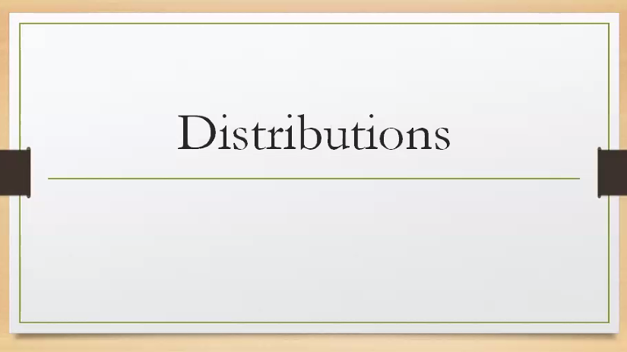

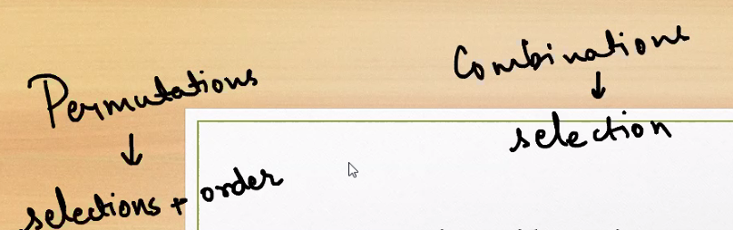

What is permutations and combinations, what is the common part in both of them.

**Permutations**

* **Definition:** Ordered arrangements of objects.
* **Formula:**
$$P(n,r)=\frac{n!}{(n-r)!}$$

* **Key Idea:** **Order matters.**
* **Example:** Choosing 2 letters from {A, B, C}:
  + Permutations: AB, BA, AC, CA, BC, CB → 6 total.

**🔹 Combinations**

* **Definition:** Selections of objects without regard to order.
* **Formula:**
$$C(n,r)=\frac{n!}{r!(n-r)!}$$

* **Key Idea:** **Order does not matter.**
* **Example:** Choosing 2 letters from {A, B, C}:
  + Combinations: {A,B}, {A,C}, {B,C} → 3 total.

**🔹 Common Part Between Both**

* Both deal with **counting selections from a set of $n$ objects**.
* Both use **factorials ($n!$)** in their formulas.
* Both are part of **combinatorics** (the branch of mathematics concerned with counting and arrangements).
* The difference is simply whether **order matters (permutation)** or **order doesn’t matter (combination)**.

**Quick Comparison Table**

| **Aspect** | **Permutations** | **Combinations** |
| --- | --- | --- |
| Order importance | ✅ Yes | ❌ No |
| Formula | $$\frac{n!}{(n-r)!}$$ | $$\frac{n!}{r!(n-r)!}$$ |
| Example (n=3, r=2) | AB, BA, AC, CA, BC, CB → 6 | {A,B}, {A,C}, {B,C} → 3 |
| Commonality | Both count selections using factorials | Both count selections using factorials |

👉 In short: **Permutations and combinations are two sides of the same coin—both count arrangements, but permutations care about order while combinations don’t.**

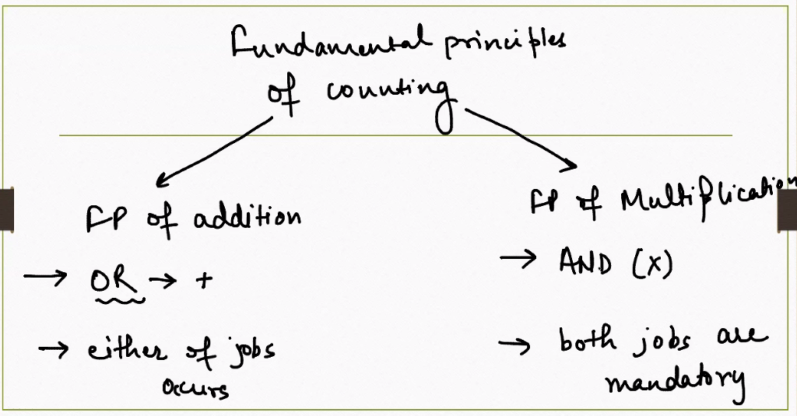

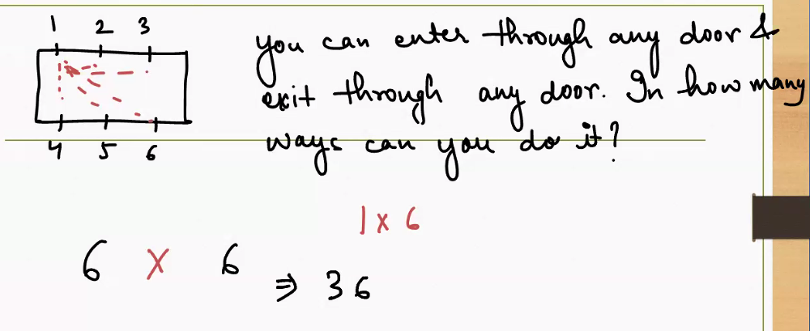

You can enter in 6 ways and exit in 6 ways, hence

6 * 6 = 36 ways

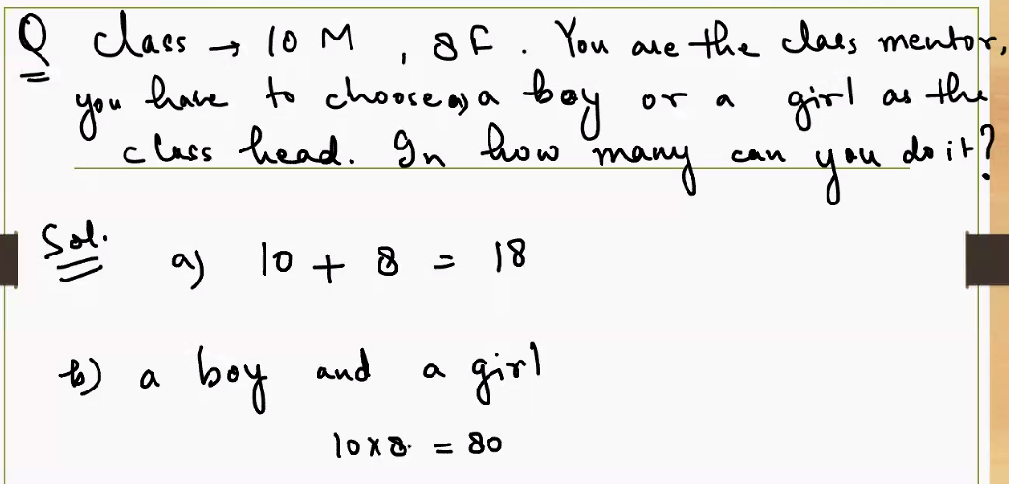

**Problem Setup**

You’re mentoring a class with:

* **10 boys**
* **8 girls**

You need to choose a **class head**, and the question is:

“In how many ways can you do it?”

**✅ Case A: Choose either a boy or a girl**

This is a **simple selection**:

* You can choose **1 out of 10 boys** → 10 ways
* Or **1 out of 8 girls** → 8 ways

So total number of ways:

$$10+8=18$$

**✅ Case B: Choose a boy and a girl together**

This is a **pair selection**:

* Choose **1 boy** → 10 choices
* Choose **1 girl** → 8 choices

So total number of ways:

$$10×8=80$$

**🔍 Key Difference Between the Two Cases**

| **Case** | **Selection Type** | **Formula** | **Result** |
| --- | --- | --- | --- |
| A | One person (boy **or** girl) | $$10+8$$ | 18 ways |
| B | Two people (boy **and** girl) | $$10×8$$ | 80 ways |

**🧠 Why This Matters**

* Case A is a **single choice** from two groups.
* Case B is a **combined choice** — one from each group.
* This is a great example of how **addition vs multiplication** rules work in counting:
  + Use **addition** when choosing from **either group**.
  + Use **multiplication** when choosing **one from each group**.

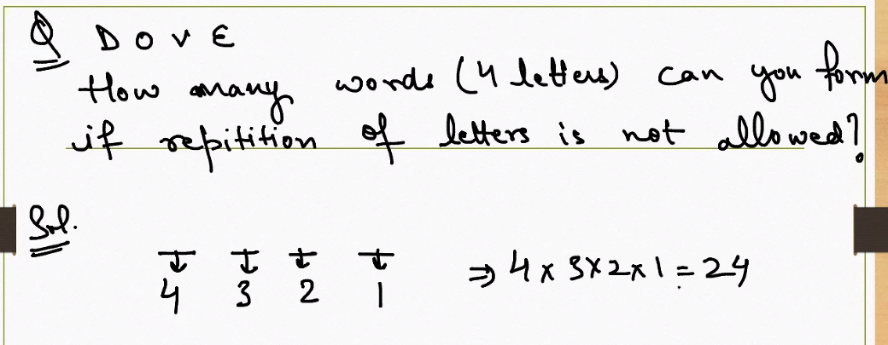

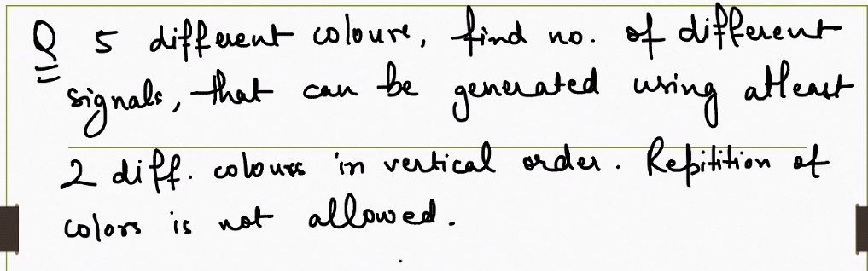

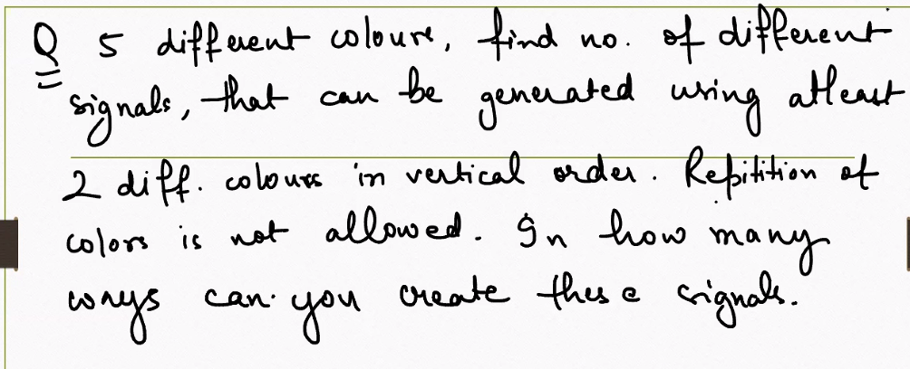

**Signals using five colors in vertical order without repetition**

You have 5 distinct colors. A “signal” is an ordered stack (top to bottom), and you must use at least 2 colors with no repetition. That means sequence length $k$ can be $2,3,4,$ or $5$, and order matters.

**Counting by sequence length**

* **Length 2:**
$$P(5,2)=5×4=20$$

* **Length 3:**
$$P(5,3)=5×4×3=60$$

* **Length 4:**
$$P(5,4)=5×4×3×2=120$$

* **Length 5:**

$$P(5,5)=5×4×3×2×1=120$$

**Total number of signals**

* **Sum across lengths:**

$$\text{Total}=P(5,2)+P(5,3)+P(5,4)+P(5,5)=20+60+120+120=320$$

**Why permutations?**

* **Order matters:** Vertical arrangement changes the signal.
* **No repetition:** Each color can appear at most once.
* **At least two colors:** Excludes length 1 sequences. exclude 1-color signals.

**\*\* A signal can be generated using atleast 2 colors, atmost it can be anything \*\***

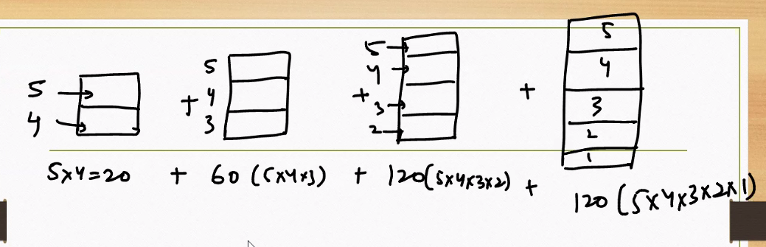

$n!$**(n factorial) is the product of all positive integers from 1 up to $n$. It’s a fundamental concept in combinatorics, used to count arrangements and solve probability problems.**

**n!=n×(n−1)×(n−2)×⋯×2×1**

**Where It’s Used**

* **Permutations: $P(n,r)=\frac{n!}{(n-r)!}$**
* **Combinations: $C(n,r)=\frac{n!}{r!(n-r)!}$**
* **Probability & Statistics: factorials help count outcomes**
* **Algorithms: factorial growth often appears in recursive problems**



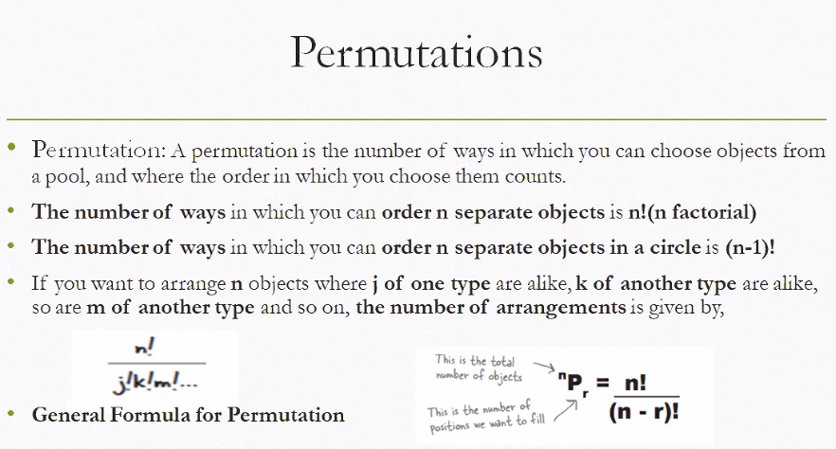

**What Is a Permutation?**

**A permutation is an arrangement of objects where order matters. For example, arranging A, B, C gives: ABC, ACB, BAC, BCA, CAB, CBA → 6 permutations.**

**📚 Key Concepts from the Image**

**1. Linear Permutations**

* **Definition: Arranging $n$ distinct objects in a line.**
* **Formula:**
$$n!=n×(n-1)×⋯×1$$

* **Example: 4 books on a shelf → $4!=24$ ways**

**2. Circular Permutations**

* **Definition: Arranging $n$ objects in a circle (rotations count as same).**
* **Formula:**
$$(n-1)!$$

* **Example: 5 people around a round table → $4!=24$ circular arrangements**

**3. Permutations with Repetition of Identical Items**

* **Definition: Some items are repeated, so we divide to avoid overcounting.**
* **Formula:**
$$\frac{n!}{j!⋅k!⋅m!…}$$

* **Example: Arranging letters in “BALLOON”**
  + **Total letters: 7**
  + **Repeats: L (2), O (2)**
  + **Permutations:**

$$\frac{7!}{2!⋅2!}=\frac{5040}{4}=1260$$

**4. General Formula for Permutations (nPr)**

* **Definition: Choosing and arranging $r$ items from $n$ distinct items.**
* **Formula:**
$$nPr=\frac{n!}{(n-r)!}$$

* **Example: Choosing 3 out of 5 students for president, VP, and secretary → $5P3=\frac{5!}{2!}=60$**

**🧠 Summary Table**

| **Type** | **Formula** | **Order Matters?** |
| --- | --- | --- |
| **Linear permutation** | $$n!$$ | **✅ Yes** |
| **Circular permutation** | $$(n-1)!$$ | **✅ Yes** |
| **With repeated items** | $$\frac{n!}{j!k!m!…}$$ | **✅ Yes** |
| **Partial permutation (nPr)** | $$\frac{n!}{(n-r)!}$$ | **✅ Yes** |

**1. Linear Permutations**

📘 Definition

Arranging $n$ distinct items in a straight line — order matters, and no repetition.

🧮 Formula

$$n!=n×(n-1)×⋯×1$$

✅ Example

Arrange 4 books on a shelf:

$$4!=4×3×2×1=24\text{ ways}$$

**🔹 2. Circular Permutations**

📘 Definition

Arranging $n$ distinct items in a circle — rotations count as the same, so one position is fixed.

🧮 Formula

$$(n-1)!$$

**In straight line arrangements can be identified but not in circle, there is no start and end point in circle.**

✅ Example

Arrange 5 people around a round table:

$$(5-1)!=4!=24\text{ circular arrangements}$$

**🔹 3. Permutations with Repetition of Identical Items**

📘 Definition

Some items are repeated, so we divide to avoid overcounting identical arrangements.

🧮 Formula

$$\frac{n!}{j!⋅k!⋅m!…}$$

Where:

* $n$ = total items
* $j,k,m,…$ = counts of identical items

✅ Example

Arrange letters in “BALLOON”:

* Total letters: 7
* Repeats: L (2), O (2)

$$\frac{7!}{2!⋅2!}=\frac{5040}{4}=1260\text{ unique arrangements}$$

**🔹 4. Partial Permutations (nPr)**

📘 Definition

Choosing and arranging $r$ items from $n$ distinct items — order matters, no repetition.

🧮 Formula

$$nPr=\frac{n!}{(n-r)!}$$

✅ Example

Choose 3 out of 5 students for president, VP, and secretary:

$$5P3=\frac{5!}{(5-3)!}=\frac{120}{2}=60\text{ ways}$$

📊 Summary Table

| Type | Formula | Order Matters | Repetition Allowed | Example |
| --- | --- | --- | --- | --- |
| Linear Permutation | $$n!$$ | ✅ Yes | ❌ No | Books on shelf |
| Circular Permutation | $$(n-1)!$$ | ✅ Yes | ❌ No | People at round table |
| With Repetition of Identical Items | $$\frac{n!}{j!k!m!…}$$ | ✅ Yes | ✅ Yes (within types) | Word “BALLOON” |
| Partial Permutation (nPr) | $$\frac{n!}{(n-r)!}$$ | ✅ Yes | ❌ No | Selecting 3 leaders from 5 |

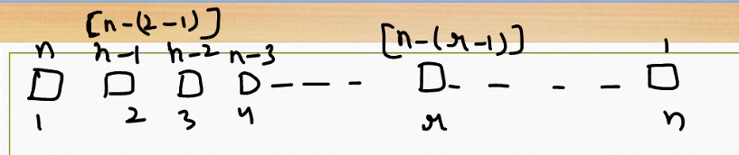

You have a sequence of positions labeled from 1 to $n$ (bottom row), and above each position is a corresponding expression (top row):

* Top row: $n,n-1,n-2,…,n-(k-1),…,1$
* Bottom row: $1,2,3,…,k,…,n$

🔁 What This Represents

This is a reverse indexing pattern — for each position $i$ from the left (1-based), the corresponding reverse index is:

$$\text{Reverse Index}=n-(i-1)$$

So:

* Position 1 → $n-(1-1)=n$
* Position 2 → $n-(2-1)=n-1$
* Position 3 → $n-(3-1)=n-2$
* ...
* Position $k$ → $n-(k-1)$

🧠 Why It’s Useful

This pattern helps when:

* Accessing elements from the end of a list using forward indices
* Mapping left-to-right positions to right-to-left values
* Designing algorithms that need mirrored traversal, like palindromes or symmetric operations

Python Example

n = 10

for i in range(1, n+1):

reverse_index = n - (i - 1)

print(f"Position {i} → Reverse index: {reverse_index}")

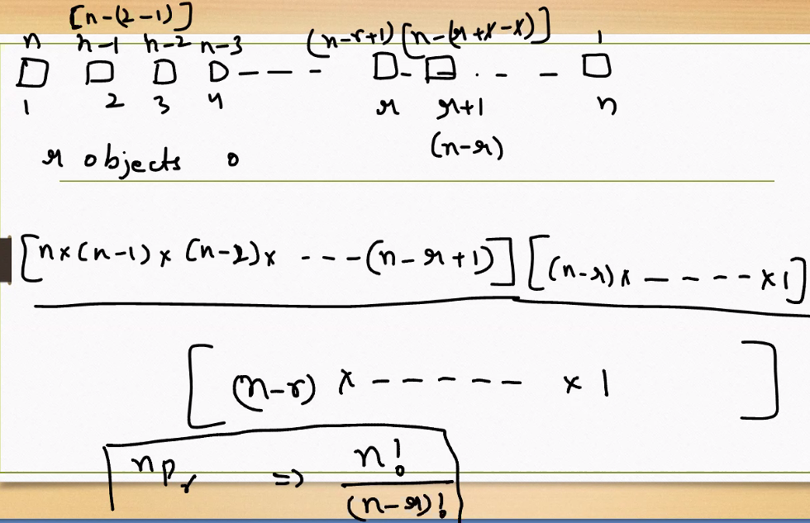

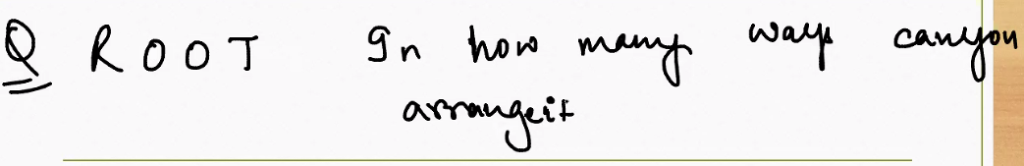

**Problem Statement**

How many distinct ways can you arrange the letters in the word **ROOT**?

**🔍 Step-by-Step Breakdown**

**1. Total letters:**

* R, O, O, T → 4 letters

**2. Repetition:**

* The letter **O** appears **twice**

**3. Formula for permutations with repetition:**

$$\text{Total arrangements}=\frac{n!}{\text{(repeated letters)!}}=\frac{4!}{2!}$$

**4. Calculation:**

$$\frac{4!}{2!}=\frac{24}{2}=12$$

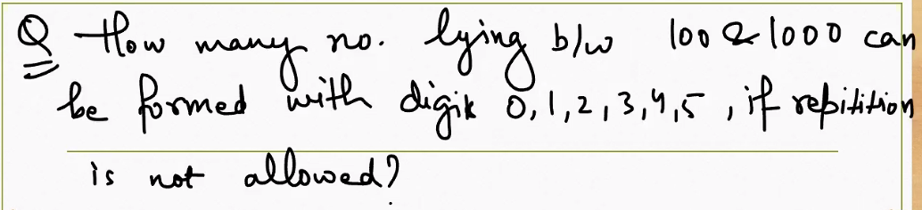

**Step-by-Step Breakdown**

**✅ Key Constraints:**

* Numbers must be **3-digit** (i.e., between 100 and 999)
* Digits available: {0, 1, 2, 3, 4, 5} → 6 digits total
* **No repetition allowed**
* First digit (hundreds place) **cannot be 0**

**🔢 Step 1: Choose the hundreds digit**

* Valid digits for the first digit: {1, 2, 3, 4, 5} → **5 choices** (0 is not allowed)

**🔢 Step 2: Choose the tens digit**

* After choosing the first digit, one digit is used
* Remaining digits: 5
* But 0 is now allowed → **5 choices**

**🔢 Step 3: Choose the units digit**

* Two digits used already
* Remaining digits: 4 → **4 choices**

**✅ Total 3-digit numbers:**

$$\text{Total}=5×5×4=\boxed{100}$$

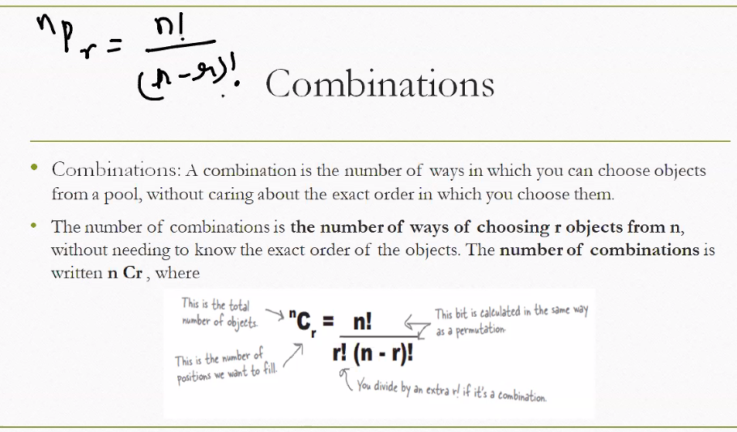

**If you remove order from Permutations, Combinations is left.**

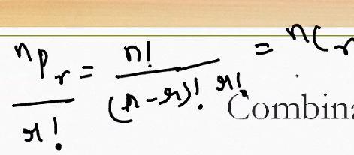

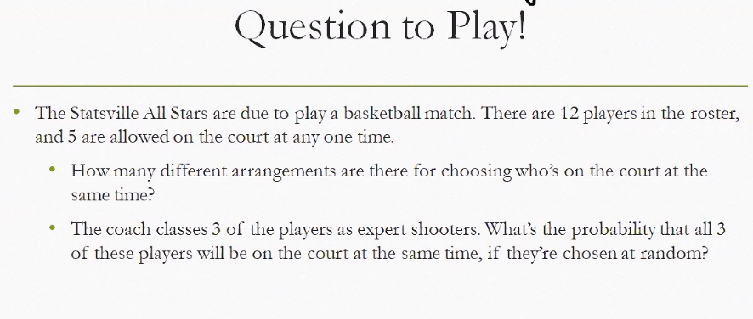

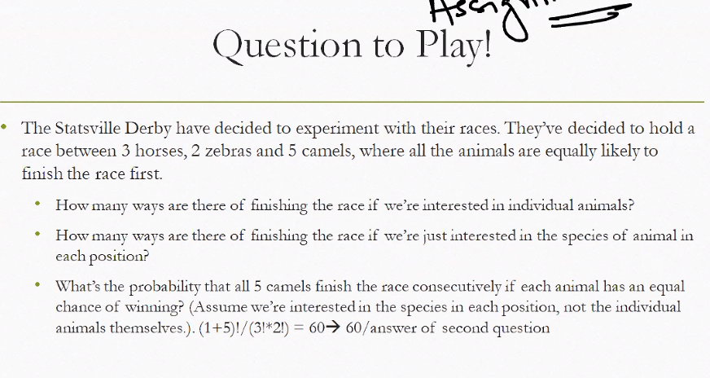

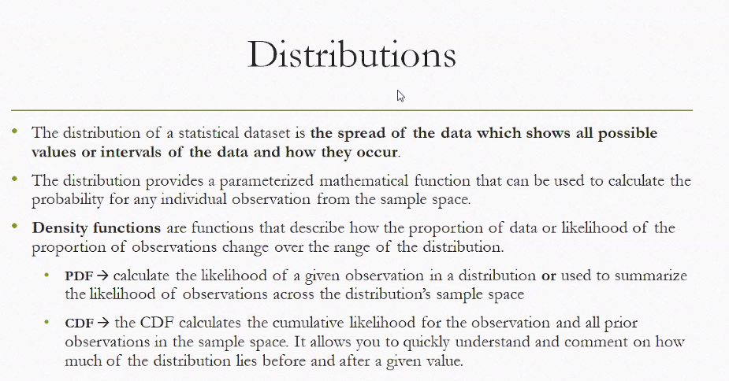

**What Is a Distribution?**

* A **distribution** shows how data values are spread across a dataset.
* It includes **all possible values or intervals** and how frequently they occur.
* Distributions are often represented using **mathematical functions** that help us calculate probabilities.

**📈 Density Functions**

These are mathematical tools that describe how likely different values are within a distribution.

**1. PDF – Probability Density Function**

* Tells you the **likelihood of a specific value** occurring in a continuous distribution.
* Can also summarize how likely values are across the entire sample space.
* Example: In a normal distribution, the PDF shows the familiar bell curve.

**2. CDF – Cumulative Distribution Function**

* Calculates the **total probability** of a value and everything **less than or equal to it**.
* Helps you understand how much of the distribution lies **before or after** a given value.
* Example: If the CDF of 70 is 0.85, it means 85% of the data is ≤ 70.

**🧠 Why It Matters**

* PDFs and CDFs are foundational in **probability theory**, **statistical modeling**, and **machine learning**.
* They help answer questions like:
  + “What’s the chance of getting a value above 90?”
  + “How much of the data lies below 50?”

**PDF vs CDF Explained**

**🔹 PDF – Probability Density Function**

* Describes the **likelihood** of a specific value occurring in a continuous distribution.
* The **area under the curve** between two values gives the probability of falling within that range.
* The curve is **not cumulative** — it shows how dense the probability is at each point.

**🔹 CDF – Cumulative Distribution Function**

* Describes the **total probability** of a value and everything **less than or equal to it**.
* Always increases from 0 to 1.
* Helps answer questions like: “What’s the probability that a value is ≤ x?”

**📌 Example: Normal Distribution (Mean = 50, SD = 10)**

Let’s say we want to understand the probability behavior around the value **x = 60**.

* **PDF(60)** gives the **density** at 60 — it’s not a probability, but a relative likelihood.
* **CDF(60)** gives the **cumulative probability** — e.g., “What’s the chance a value is ≤ 60?”

If CDF(60) = 0.84, it means **84% of the data lies below 60**.

**📉 Visual Comparison**

The image below shows:

* **Left:** PDF — bell-shaped curve peaking at the mean.
* **Right:** CDF — S-shaped curve rising from 0 to 1.
* Both curves are aligned at the same value of **x**, showing how PDF gives density and CDF gives cumulative probability.

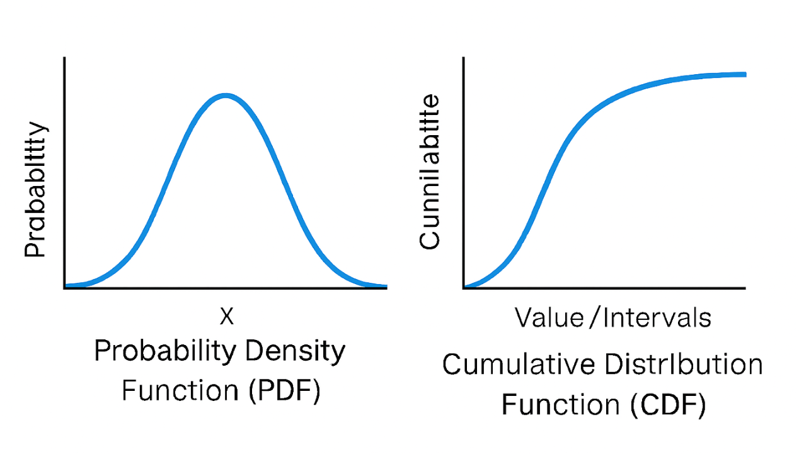

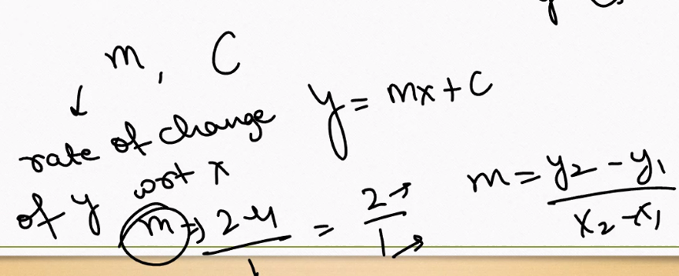

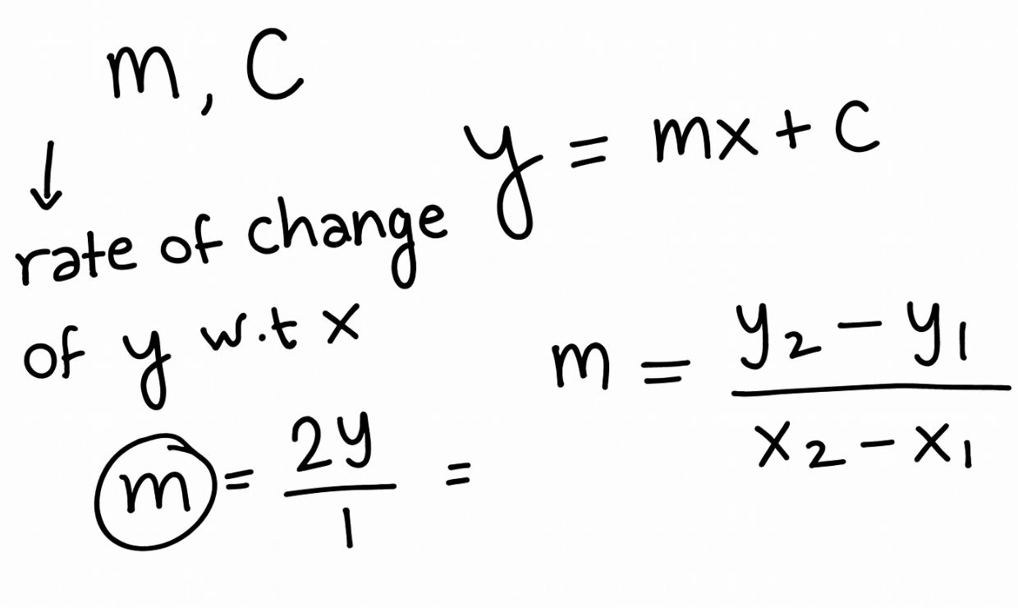

**Key Concepts Explained**

**1. Slope (m)**

* Described as the **rate of change of y with respect to x**.
* It tells you how steep a line is — how much y changes when x increases by 1 unit.

**2. Slope Formula**

$$m=\frac{y_{2}-y_{1}}{x_{2}-x_{1}}$$

* This formula calculates the slope between two points $(x_{1},y_{1})$ and $(x_{2},y_{2})$.
* It measures the vertical change divided by the horizontal change.

**3. Slope-Intercept Form**

$$y=mx+c$$

* This is the equation of a straight line.
* $m$ is the slope, and $c$ is the y-intercept (where the line crosses the y-axis).

**4. Example Calculation**

* The notes show:
$$m=\frac{2}{1}$$

* This means the slope is 2, so for every 1 unit increase in x, y increases by 2 units.

**📌 Interpretation Summary**

* The notes define slope as a rate of change.
* They show how to calculate slope between two points.
* They use the slope-intercept form to describe linear relationships.
* The example illustrates a line with slope 2.

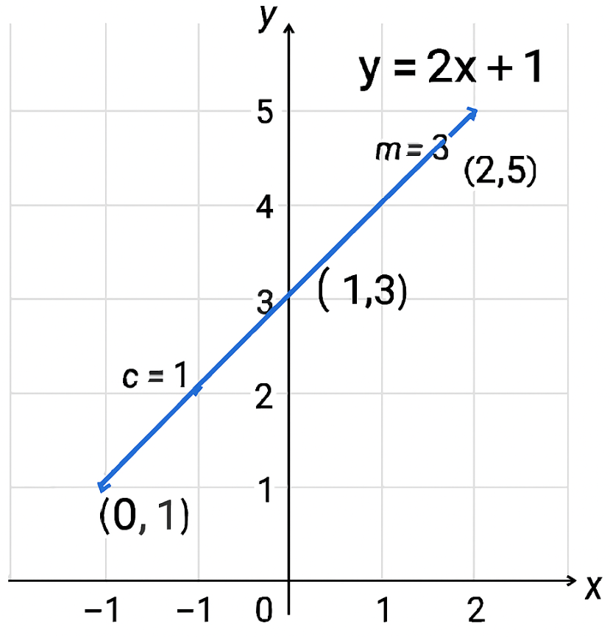

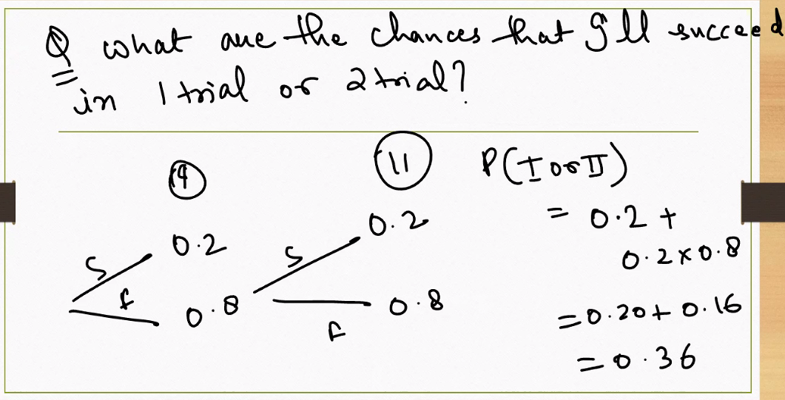

The chances of learning a Snow-boarding.

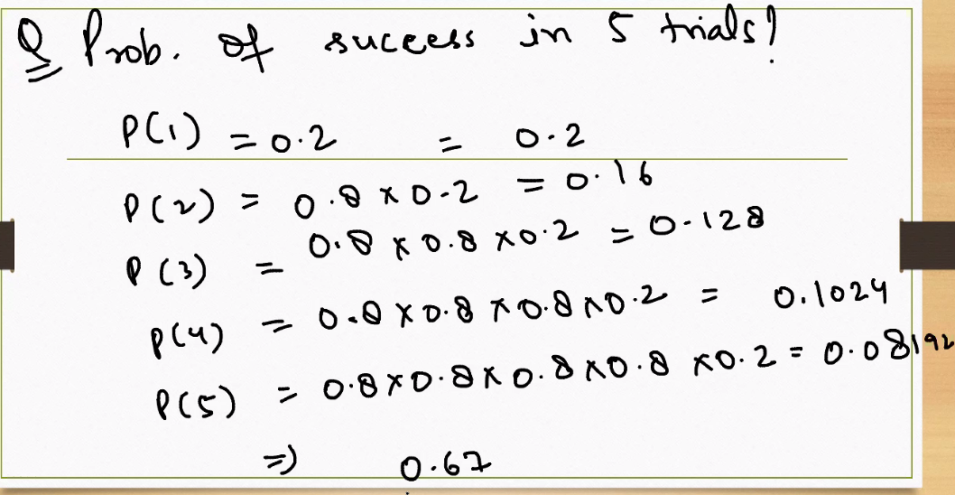

**At each subsequent the probability of success is falling.**

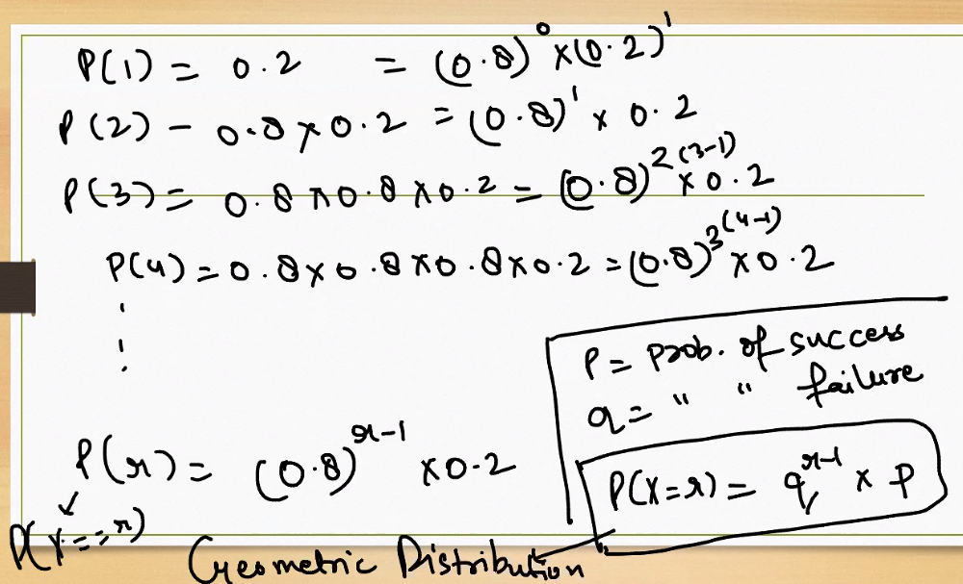

This image explains the **geometric probability distribution**, which models the probability of the **first success occurring on the x-th trial** in a sequence of independent trials — each with the same probability of success.

**🎯 Core Formula**

$$P(X=x)=q^{x-1}⋅p$$

Where:

* $P(X=x)$ = probability that the first success occurs on trial $x$
* $p$ = probability of success on each trial (here, $p=0.2$)
* $q=1-p$ = probability of failure (here, $q=0.8$)
* $x$ = trial number

**🔢 Trial-by-Trial Breakdown**

| **Trial** | **Expression** | **Result** |
| --- | --- | --- |
| P(1) | $${0.8}^{0}⋅0.2$$ | 0.2000 |
| P(2) | $${0.8}^{1}⋅0.2=0.8⋅0.2$$ | 0.1600 |
| P(3) | $${0.8}^{2}⋅0.2=0.64⋅0.2$$ | 0.1280 |
| P(4) | $${0.8}^{3}⋅0.2=0.512⋅0.2$$ | 0.1024 |
| P(5) | $${0.8}^{4}⋅0.2=0.4096⋅0.2$$ | 0.0819 |

**📌 Interpretation**

* This distribution answers: “What’s the probability that the **first success** happens on trial 1, 2, 3, etc.?”
* The probability **decreases with each trial**, because it assumes all previous trials failed.
* It’s useful in modeling **waiting times** — like how many attempts until a system succeeds or a user clicks.

In a **geometric distribution**, the **mode** is always:

$$\text{Mode}=1$$

**✅ Why?**

* The mode is the value of $x$ that has the **highest probability**.
* Since the geometric distribution models the probability of the **first success** occurring on trial $x$, the **first trial (x = 1)** always has the highest chance.
* After that, the probability decreases exponentially due to repeated failures.

**📌 Example Recap (with $p=0.2$, $q=0.8$):**

| **Trial** | **Probability** |
| --- | --- |
| P(1) | 0.2000 ← **Highest** |
| P(2) | 0.1600 |
| P(3) | 0.1280 |
| P(4) | 0.1024 |
| P(5) | 0.0819 |

So, **mode = 1**, because the first trial has the highest probability of success.

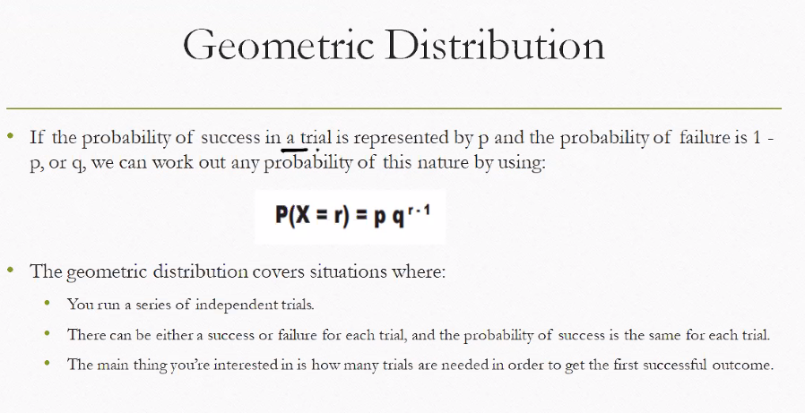

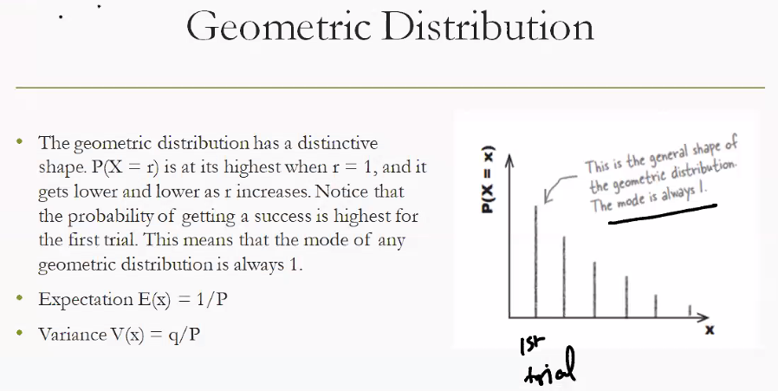

This slide provides a clear overview of the **geometric distribution**, a fundamental concept in probability theory used to model the number of trials until the first success.

**📊 What Is a Geometric Distribution?**

* It describes the probability that the **first success** occurs on the **r-th trial**.
* Each trial is independent, and the probability of success $p$ remains constant.
* The probability **decreases** as the number of trials increases — meaning success is most likely to happen early.

**🔣 Formula**

$$P(X=r)=q^{r-1}⋅p$$

Where:

* $P(X=r)$: Probability that the first success occurs on trial $r$
* $p$: Probability of success
* $q=1-p$: Probability of failure
* $r$: Trial number

**📌 Key Properties**

* **Mode**: Always **1** — the first trial has the highest chance of success.
* **Expectation (Mean)**:

$$E(X)=\frac{1}{p}$$

This tells you the average number of trials expected before the first success.

* **Variance**:

$$V(X)=\frac{q}{p^{2}}$$

This measures the spread or variability in the number of trials until success.

**📉 Graph Shape**

* The graph shows a **decreasing bar chart**:
  + Highest bar at trial 1 (mode = 1)
  + Each subsequent bar is shorter, reflecting lower probability
* This shape is typical of geometric distributions — steep drop-off after the first trial.

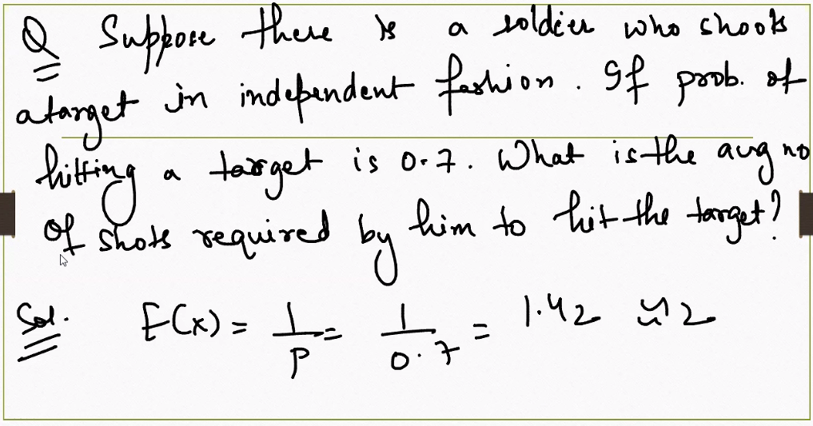

**🎯 Problem Statement**

A soldier shoots at a target independently. Probability of hitting the target on any shot = **0.7** What is the **average number of shots** required to hit the target?

**📊 Solution Using Geometric Distribution**

This models the number of trials until the **first success**. The expected value (mean) of a geometric distribution is:

$$E(X)=\frac{1}{p}$$

Where:

* $p=0.7$ (probability of success)

So,

$$E(X)=\frac{1}{0.7}≈1.43$$

**✅ Interpretation**

* On average, the soldier will require **1.43 shots** to hit the target.
* This means most hits will occur on the **first or second attempt**, with fewer cases requiring more.

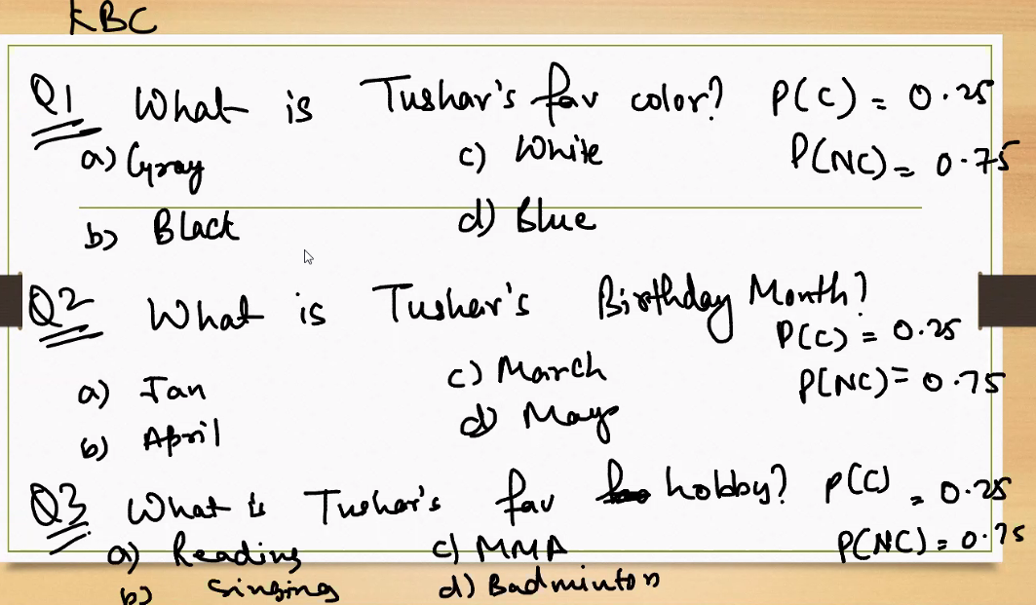

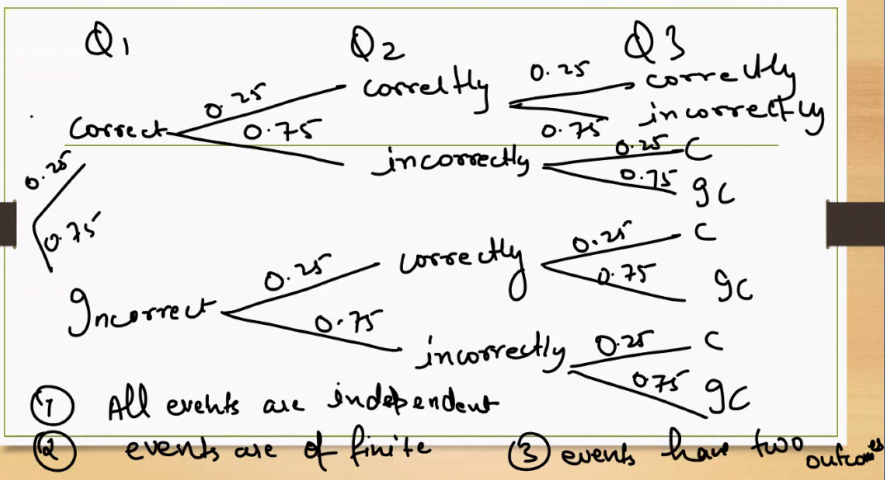

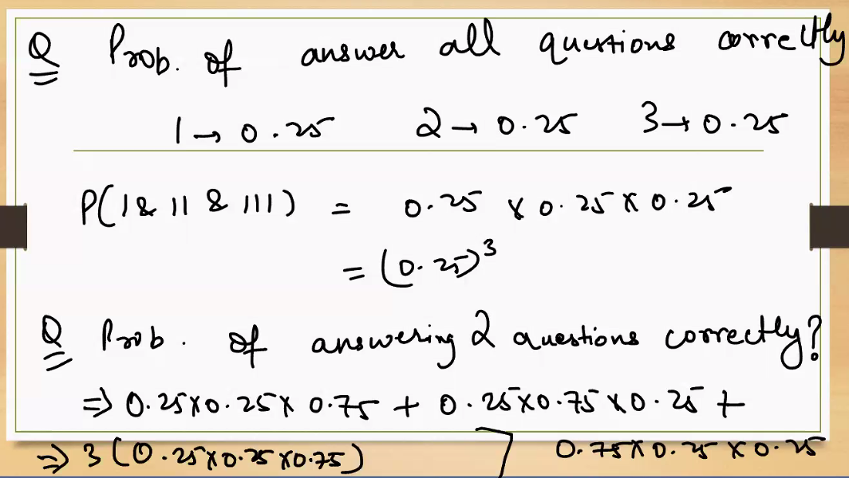

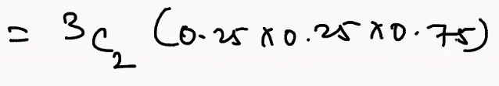

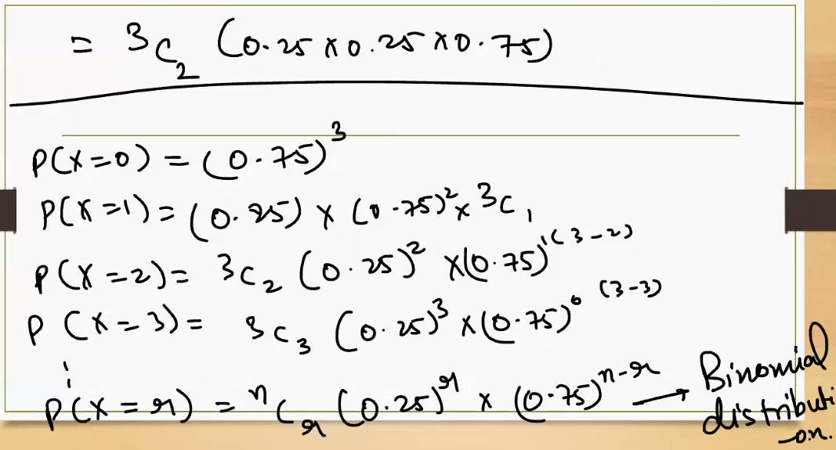

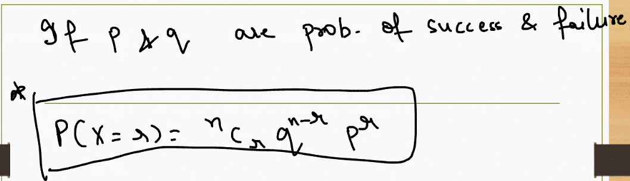

----------- Assignments ------------

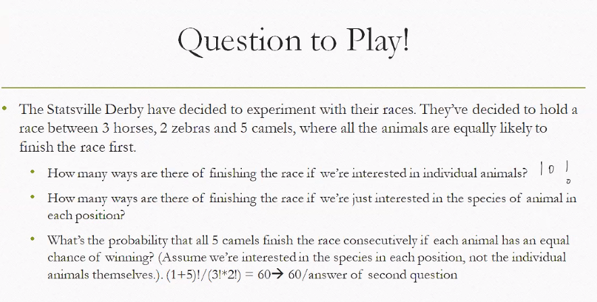

**🧠 Given:**

* Total animals: $3+2+5=10$
* All animals are **distinct individuals** unless stated otherwise.
* We're asked to consider both **individual identity** and **species identity**.

**🔹 Q1: How many ways can the animals finish the race (individual identity matters)?**

This is a **linear permutation** of 10 distinct animals:

$$10!=3628800\text{ ways}$$

**🔹 Q2: How many ways can the animals finish the race (species identity only)?**

We treat animals of the same species as **indistinguishable**.

* Total positions: 10
* Species counts: 3 horses, 2 zebras, 5 camels

Use the formula for permutations with repeated items:

$$\frac{10!}{3!⋅2!⋅5!}=\frac{3628800}{6⋅2⋅120}=\frac{3628800}{1440}=2520\text{ species-based arrangements}$$

**🔹 Q3: Probability that all 5 camels finish consecutively (species-based)**

We treat the 5 camels as a **block** that must stay together.

**Step 1: Treat the camel block as one unit**

* Remaining species units: 1 camel block + 3 horses + 2 zebras = 6 units
* Ways to arrange these 6 units:

$$\frac{6!}{3!⋅2!}=\frac{720}{6⋅2}=60$$

**Step 2: Total species-based arrangements (from Q2): 2520**

**Step 3: Probability:**

$$\frac{60}{2520}=\frac{1}{42}≈0.0238$$

**✅ Final Answers**

| **Question** | **Answer** |
| --- | --- |
| Q1 | 3628800 ways |
| Q2 | 2520 ways |
| Q3 | Probability = $\frac{1}{42}$ |



**Given:**

* Total players: **12**
* Players on court at a time: **5**
* Among them, **3 are expert shooters**

**🔹 Q1: How many different arrangements are there for choosing who’s on the court?**

This is a **combination problem** — we’re choosing 5 players from 12, and **order doesn’t matter**.

$$\text{Ways}=({12 \atop 5})=\frac{12!}{5!(12-5)!}=\frac{12!}{5!⋅7!}=792$$

✅ **Answer: 792 different 5-player combinations**

**🔹 Q2: What’s the probability that all 3 expert shooters are on the court?**

We want to count how many of the 792 combinations include **all 3 expert shooters**.

**Step 1: Fix the 3 expert shooters (only 1 way to choose them)**

**Step 2: Choose 2 more players from the remaining 9 (non-experts)**

$$({9 \atop 2})=\frac{9!}{2!⋅7!}=36$$

So:

* **Favorable outcomes** = 36
* **Total outcomes** = 792

$$\text{Probability}=\frac{36}{792}=\frac{1}{22}≈0.0455$$

✅ **Answer: Probability = $\frac{1}{22}$ or about 4.55%**